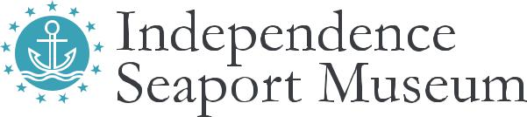
Date: _________________

Walnut2Walnut participant waiver

Boat Type: _________________ Participant Full Name: ______________________________________________

Address: __________________________________________________________________________________

Participant Cell #: ________________________ Participant Email: _____________________________________

RECOGNITION OF RISK; Participant expressly acknowledges that the risk of injury from the activities involved in this program is significant, and while particular skills, equipment, and personal discipline may reduce this risk, the risk of serious injury does exist of injury to persons and property; Participant is aware of those risks and understands them. Participant acknowledges that lifejackets are made available for use while boating, and that all boaters are required to wear lifejackets while operating any rental equipment. Participant understands that use of a lifejacket does not remove all risks of injury; nor does it make boating a safe activity. Participant alone has determined the sufficiency of any safety gear or other precautions that Participant decides to take to minimize the risks of the activity. Participant willingly agrees to comply with the stated and customary terms and conditions for participation. If, however, the participant observes any unusual significant hazard during my presence or participation, Participant will remove themselves from participation and bring such to the attention of ISM staff immediately. No party related to ISM, including Owner and Employees, has made any representations regarding the safety of, or the risks of, the activity. Participant expressly assumes the risks of the activity.

RELEASE OF LIABILITY; Participant, for themselves and on the behalf of their heirs, assigns, personal representatives and next of kin herby releases, indemnifies, and holds harmless ISM, Delaware River Waterfront Corporation and Schuylkill River Development Corporation, their officers, agents, instructors, subcontractors,­ and/or employees, other participants, sponsoring agencies, sponsors, advertisers, with respect to any and all injury, disability, death or loss or damage to person or property associated with participant’s presence or participation, whether arising from the negligence of the releases or otherwise, to the fullest extent permitted by law, including attorney fees, occurring as a result of use of said boat. This agreement constitutes the entire agreement between ISM and Participant and no term may be waived or modified (including this provision against oral modification) except in writing signed by both parties. There are no warranties, expressed or implied, by ISM to Participant, except as contained herein, and ISM shall not be liable for any loss or injury to Participant nor to anyone else, of any kind or however caused. This agreement is one of bailment only and Participant is not ISM‘S agent while using said equipment. The laws of the State of Pennsylvania shall govern this agreement.

Participant Name: __________________________Signature: _____________________________ Over 18? Y/N

211 S. Columbus Blvd., Philadelphia, PA 19106 |  | 215-413-8655 |  | phillyseaport.org

